As per my knowledge, below are my responses.

**Migration of sample database**

**Q1-**Configure the Northwind sample database from this link

Below steps I followed to solve this

1. Downloaded sql script (instnwnd.sql) from ‘Northwind-Pubs GitHub repository’ and executed on my test MS SQL database on my workspace ‘Database.PNG’ file can be referred.

**Q2-**Use any method or toolkit to migrate this to PostGRE. Create a runbook to explain the steps involved in configuration, mentioning the special aspects to be considered based on your own experience.

Below steps I followed to solve this:

1. I use Schema Conversion Tool to Migrate this database from MS Sql to PostgreSQL
2. Set source and Target Databases
3. As we can see in attached report, Tables migrated 100%
4. Views migrated 75% successfully and 25% need minor changes.
5. Procedures 43% successfully migrated and 57% need some minor changes. Most of the changes are related with substring and case sensitivity.

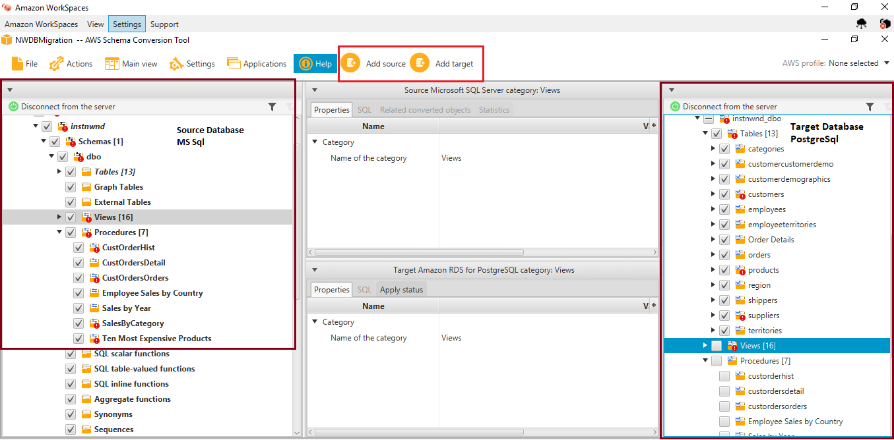

**.Q3-**Any incompatibility needs to be noted and an approach identified for fixing that out.

1. Substring related functions are incompatible.
2. Must check case sensitive names should use Lower to resolve case sensitivity issue. For eg below

**LOWER(customerid) = LOWER(par_CustomerID)**

1. Few examples

SUBSTRING(CONVERT(nvarchar(22), O.OrderDate, 111), 1, 4) = @OrdYear

**Change to** SUBSTRING(CONVERT(nvarchar(22), O.OrderDate, 111), FROM 1 FOR 4) = = @OrdYear;

SET ROWCOUNT 10

Getdate() 🡪 NOW()

1. Data Type Incompatibility

|  |  |
| --- | --- |
| **SQL Server DataTypes** | **PostgreSQL DataTypes** |
| nvarchar | varchar |
| datetime | timestamp |
| IMAGE, VARBINARY | bytea |
| ntext | text |
| INT | Integer |

**Issue list**

